**Assignment no. 9**

**1. Write a shell script to perform arithmetic operations using two operands. Take values from user.**

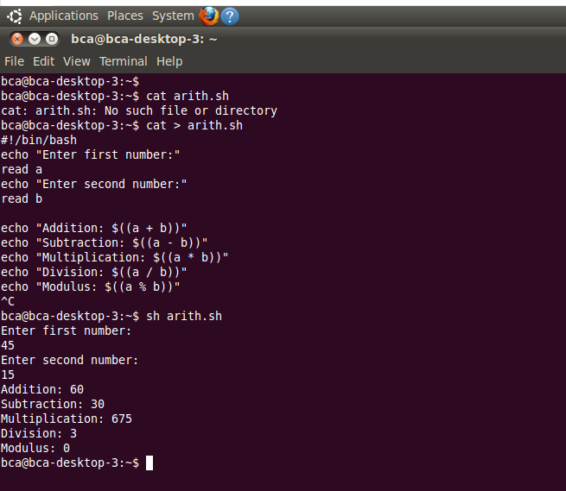

**2. Write a shell script to demonstrate the use of relational operators.**

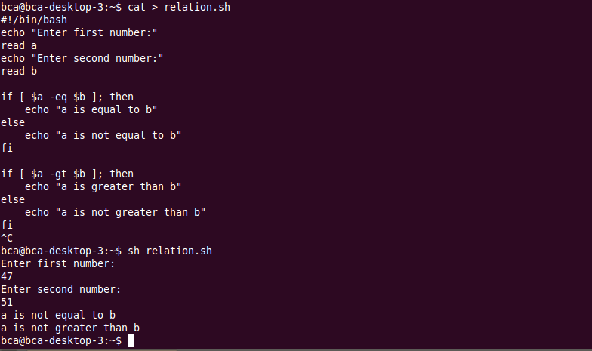

**3. Write a shell script to illustrate the use of Boolean operators.**

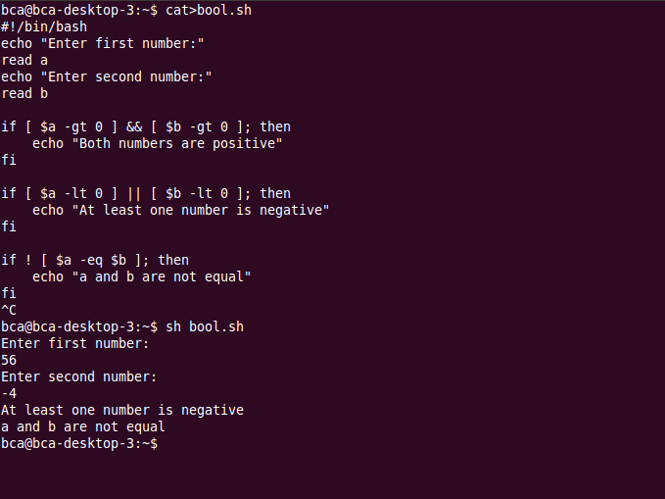

**4. Take two string values from user and check**

**a) Two values are equal or not**

**b) String operand size is zero or not**

**c) String size is zero or not.**

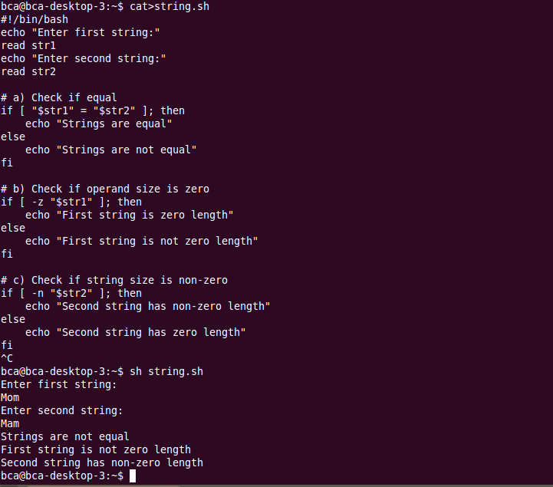

**5. Take any one file and write a script to perform following file test operations on that file.**

**a) Whether the given file has read permission or not**

**b) Whether the given file has write permission or not**

**c) Whether the given file has execute permission or not**

**d) Whether the given file is file or directory.**

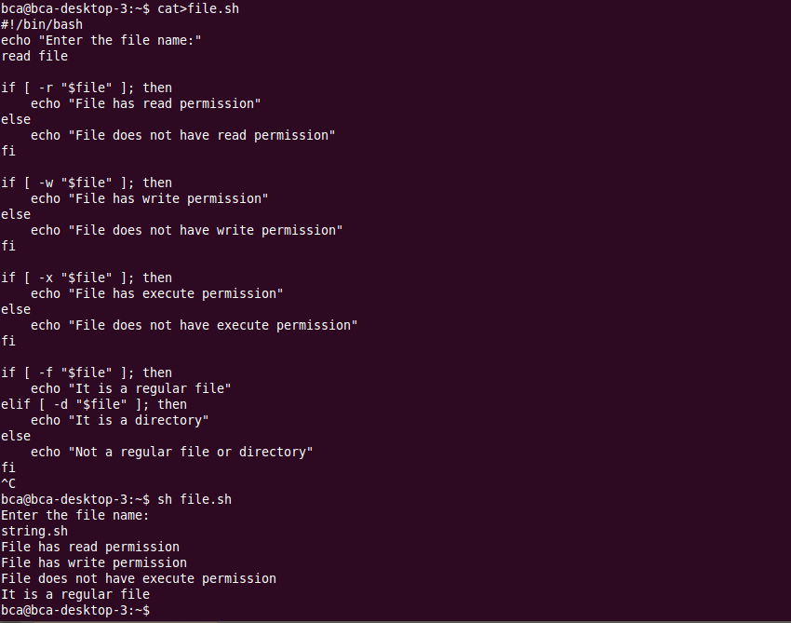

**6. write a script using case statement,**

**Take choice from user for execution of date, cal, who and grep command**

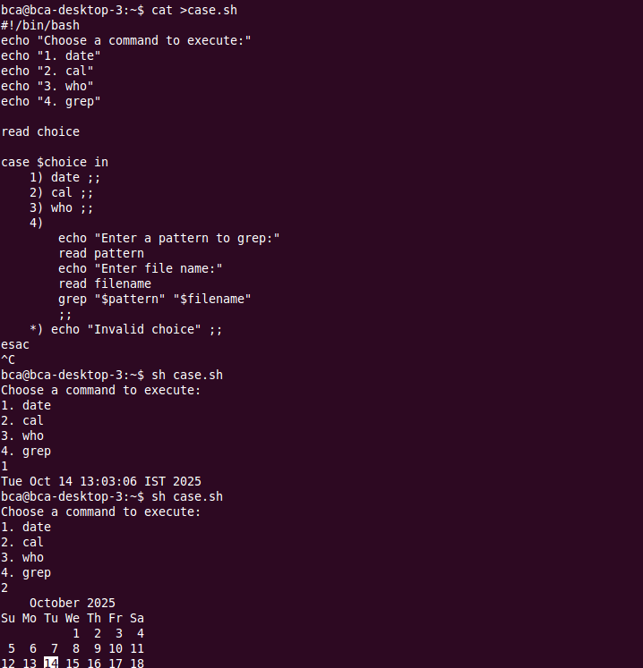

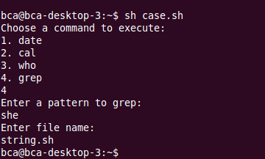

**7. Write a shell script to print the sequence 1 to 49 using while loop.**

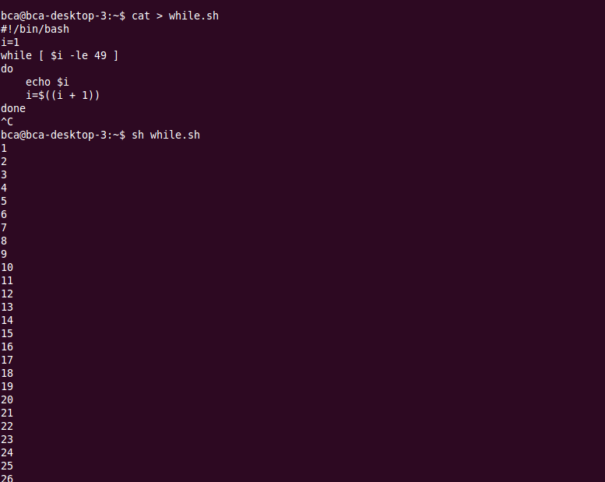

**8. Write a shell script to print the sequence 20 to 1 using until loop.**

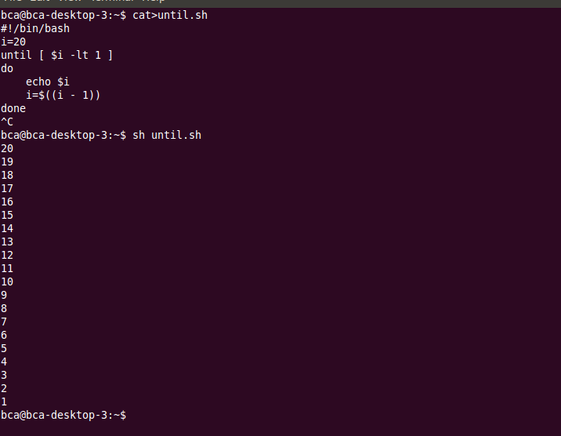

**9. Write a shell script to print the sequence 1 to 19 using for loop.**

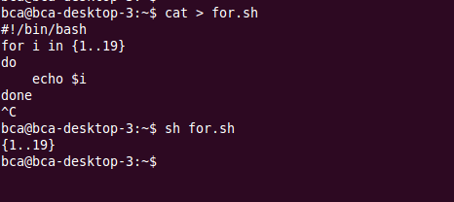

**10. Write a shell script to print the following sequence,**

**1**

**2**

**3**

**4**

**5**

**7**

**8**

**9**

**10**

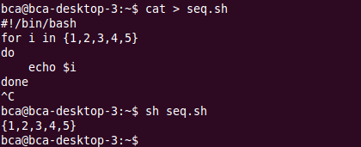

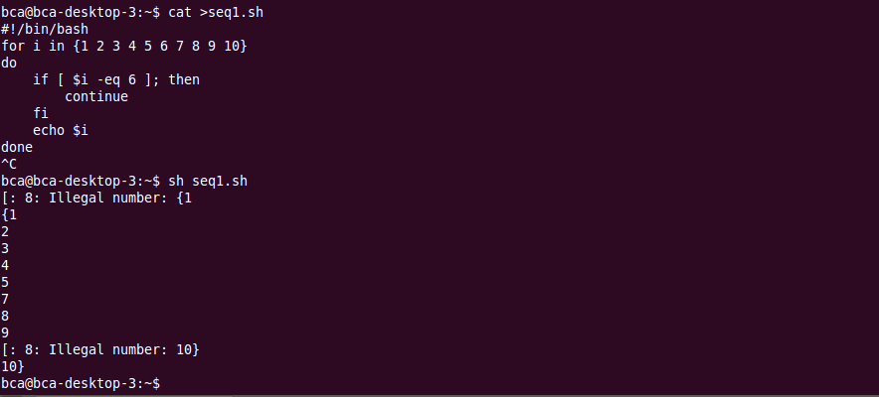

**11. Write a script that check count is equal to 25, it breaks out of the loop immediately. If count is a multiple of 5, it skips the rest of the commands and starts the next iteration. If neither condition is met, it echoes the current value of count. Initial value of Count =1**

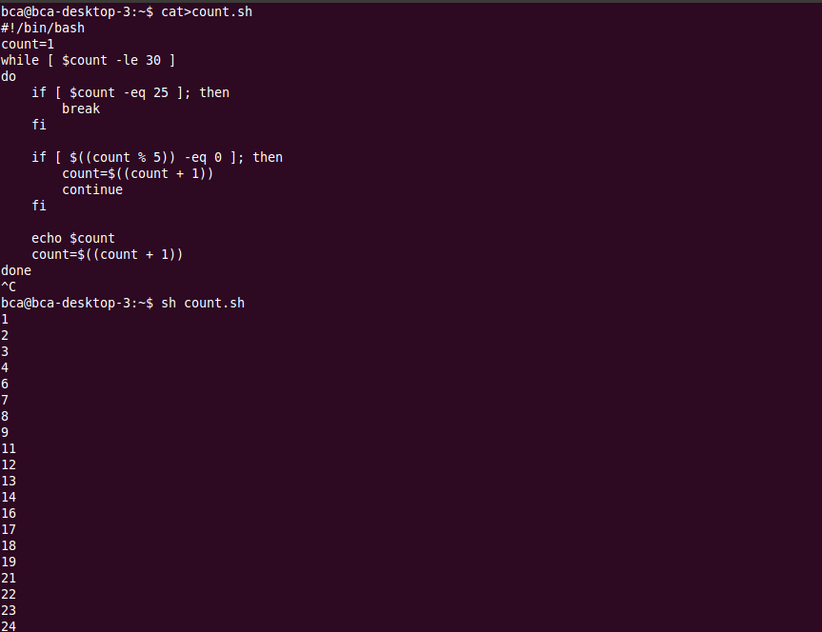

**12. Write a script to print even numbers from 1 to 50.**

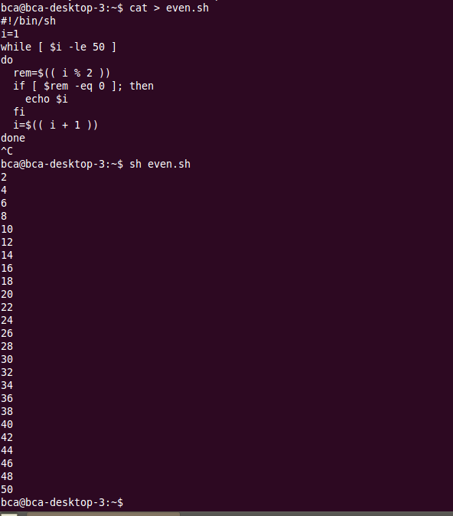

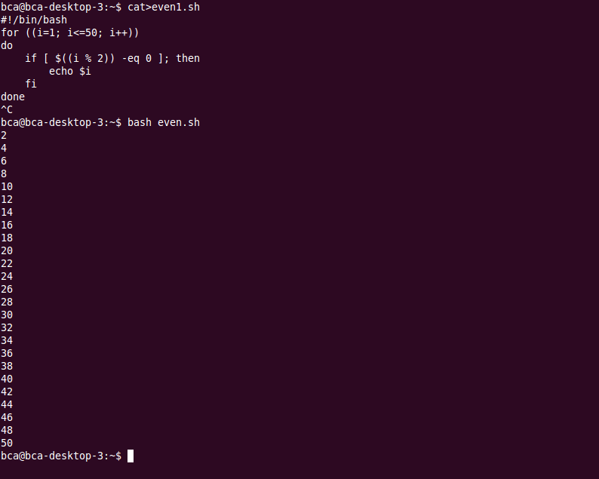

**13. Write a shell script to demonstrate the use of *Break* and *continue* keyword.**

